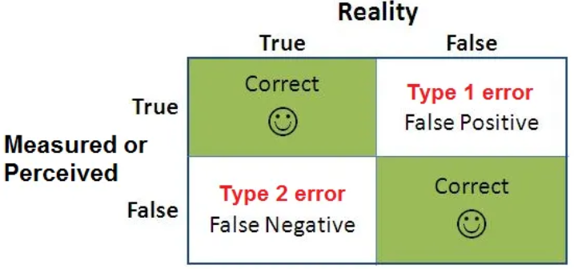

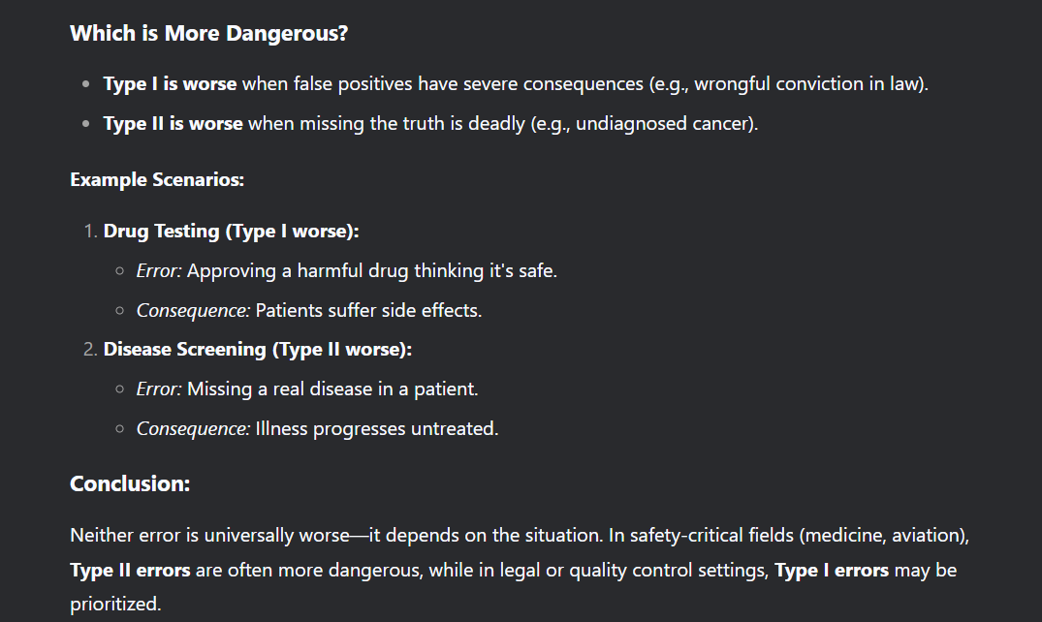

Confidence Intervals:
https://www.intellisurvey.com/blog/guide-to-calculating-confidence-intervals

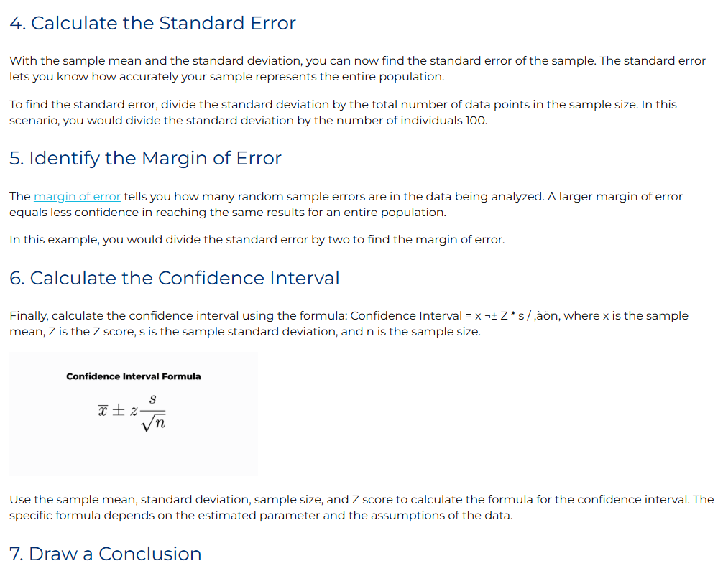

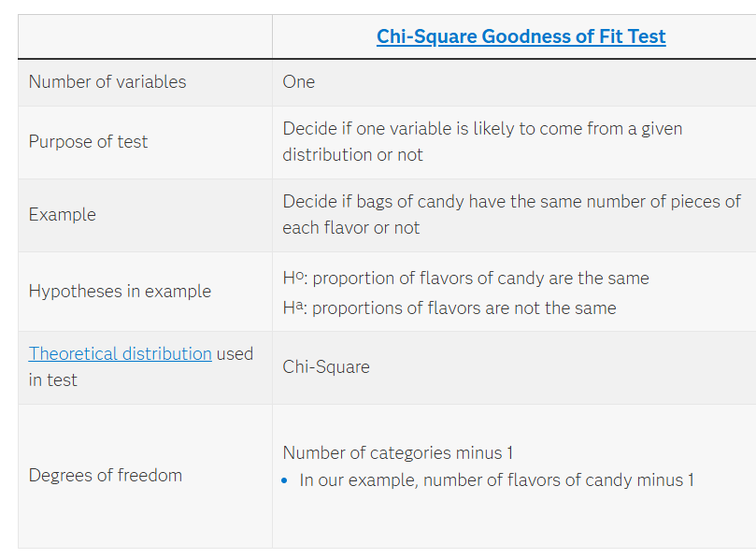
Chi – Square Test

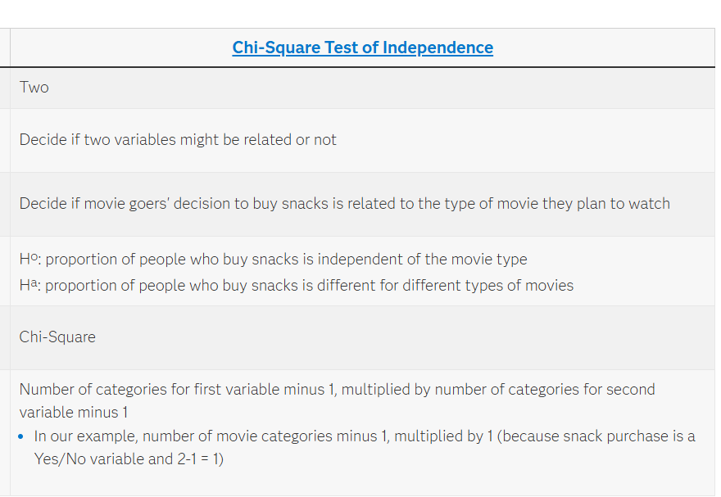

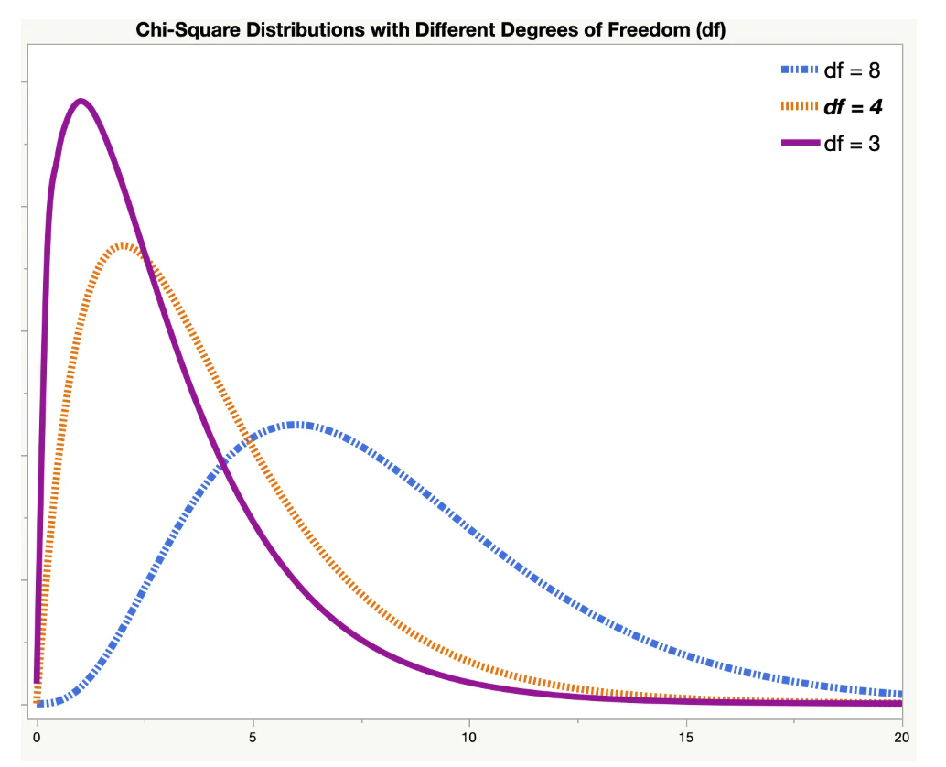
Critical value:

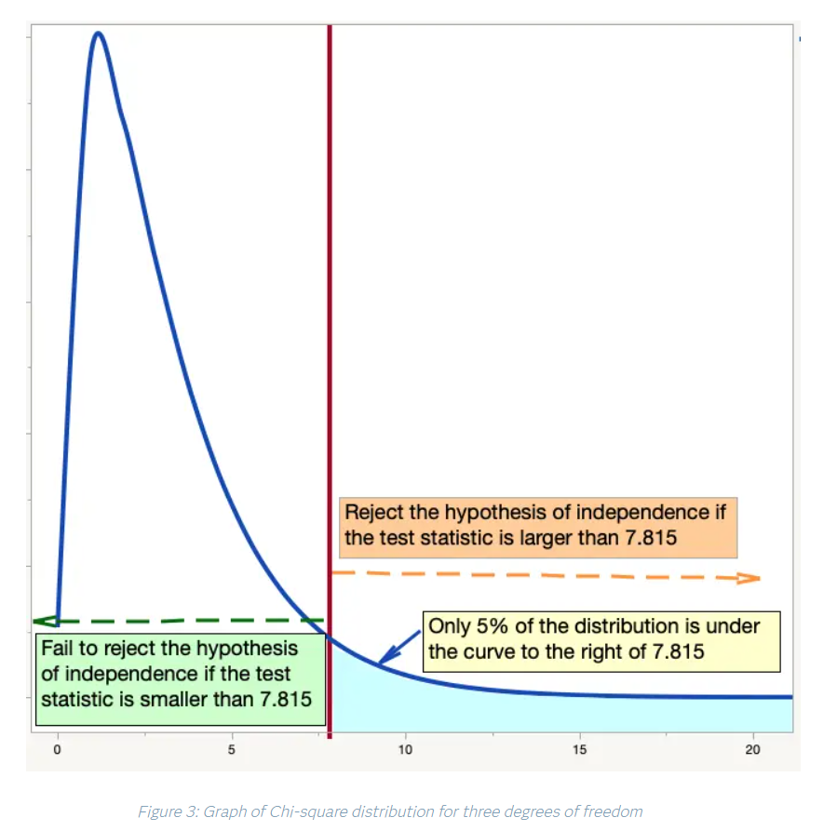

ANOVA:
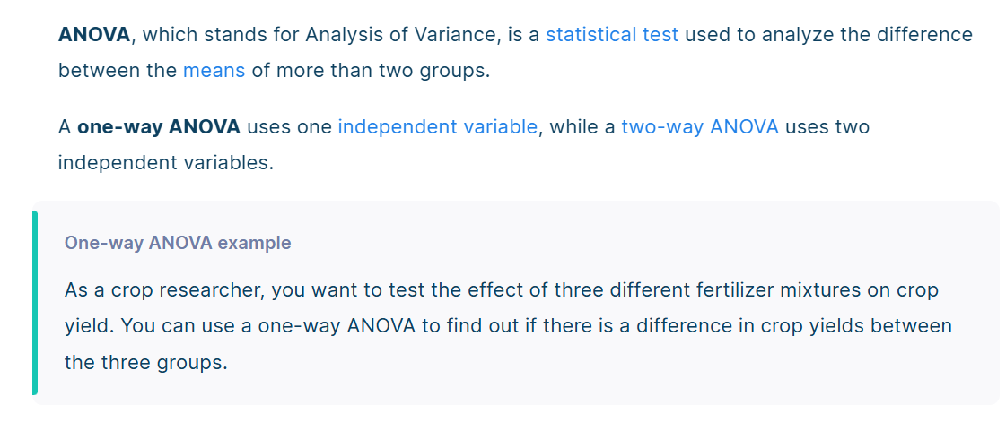
Assumptions in anova:
- Normality of sampling distribution of means (CLT):
The distribution of sample means is normally distributed.
- Absence of Outliers:
Outliers need to be removed from the dataset.
- Homogenity of Variance:
Population variance of different levels of each independent variable are equal.
- Samples are independent and randomly selected

